<http://sciencelearn.org.nz/var/sciencelearn/storage/images/contexts/just-elemental/sci-media/images/elements-in-the-human-body/173356-2-eng-NZ/Elements-in-the-human-body_full_size_landscape.jpg>

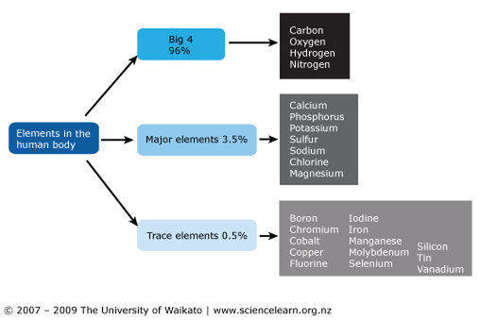

<http://www.dlt.ncssm.edu/tiger/diagrams/basics/ElementsInHumanBody.gif>

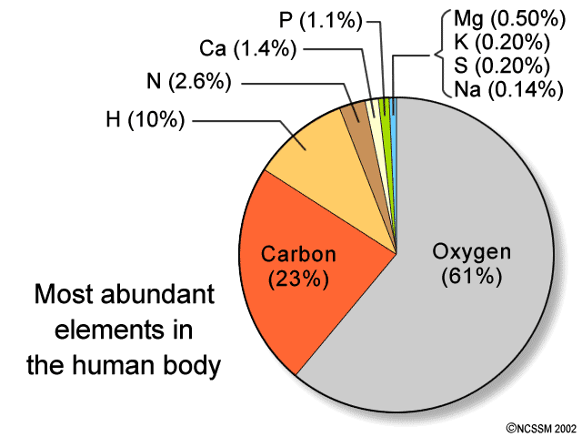

<http://askabiologist.asu.edu/sites/default/files/resources/articles/buildingblocks/13elementsgraph_550.gif>

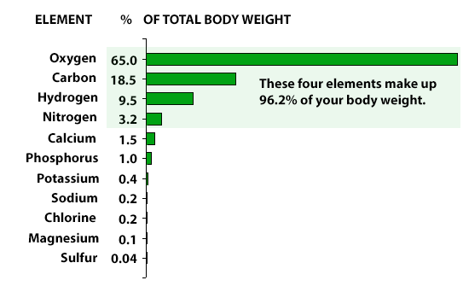

<http://askabiologist.asu.edu/sites/default/files/resources/articles/buildingblocks/periodic_table_550.gif>

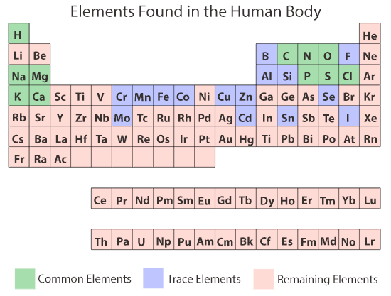

<http://upload.wikimedia.org/wikipedia/commons/thumb/f/fd/201_Elements_of_the_Human_Body-01.jpg/500px-201_Elements_of_the_Human_Body-01.jpg>

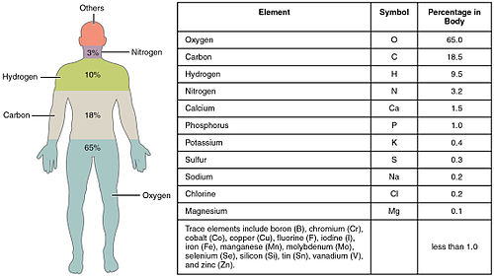

<http://circres.ahajournals.org/content/109/3/309/F1.large.jpg>

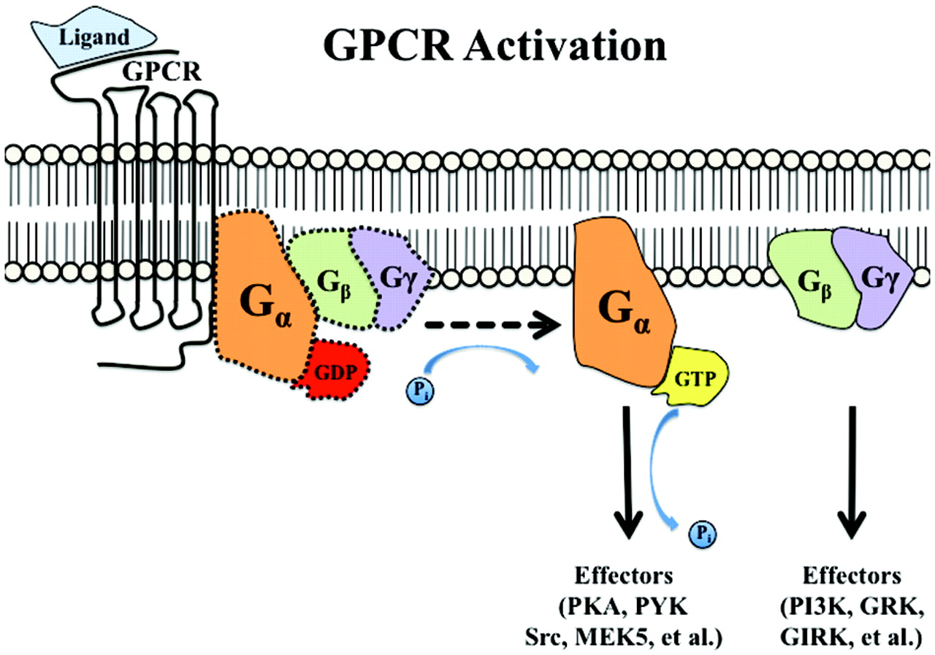

<http://figures.boundless.com/18632/full/figure-05-02-04.jpe>

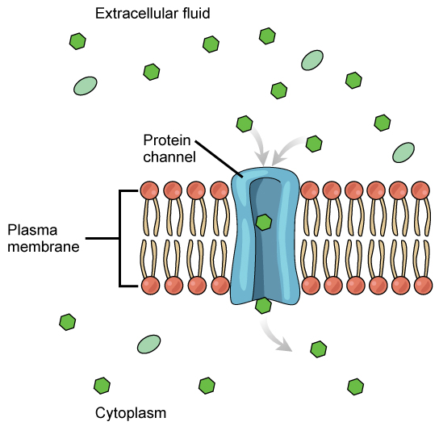

<http://www.nature.com/nrd/journal/v3/n3/images/nrd1361-f2.jpg>

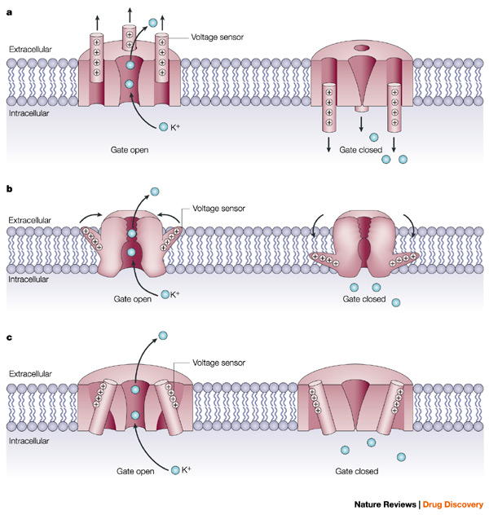

<http://www.fastbleep.com/assets/notes/image/8869_1.jpg>

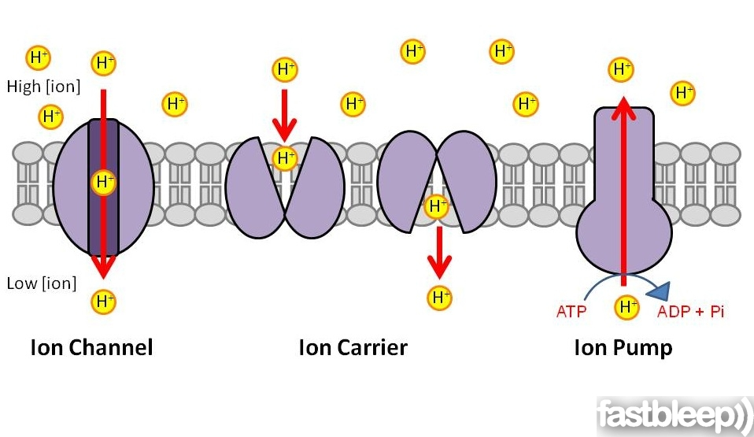

<http://apbrwww5.apsu.edu/thompsonj/Anatomy%20&%20Physiology/2010/2010%20Exam%20Reviews/Exam%203%20Review/channels.jpg>

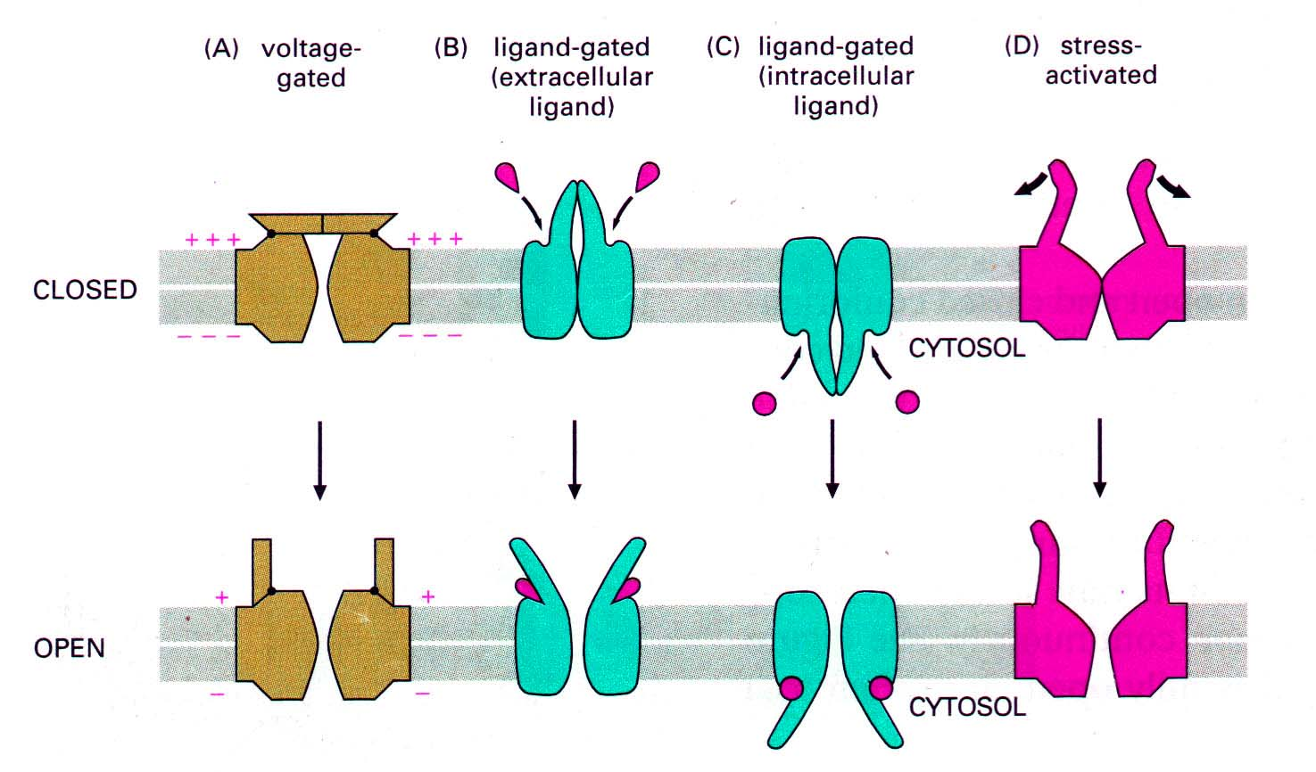

<http://ibbio.pbworks.com/f/1349911244/cell_membrane5.jpeg>

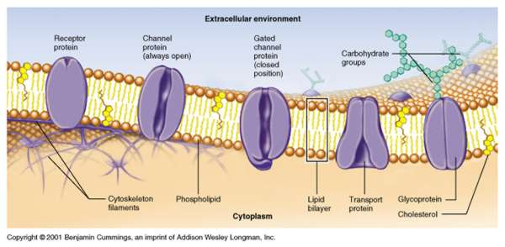

<http://jgp.rupress.org/content/137/6/521/F1.large.jpg>

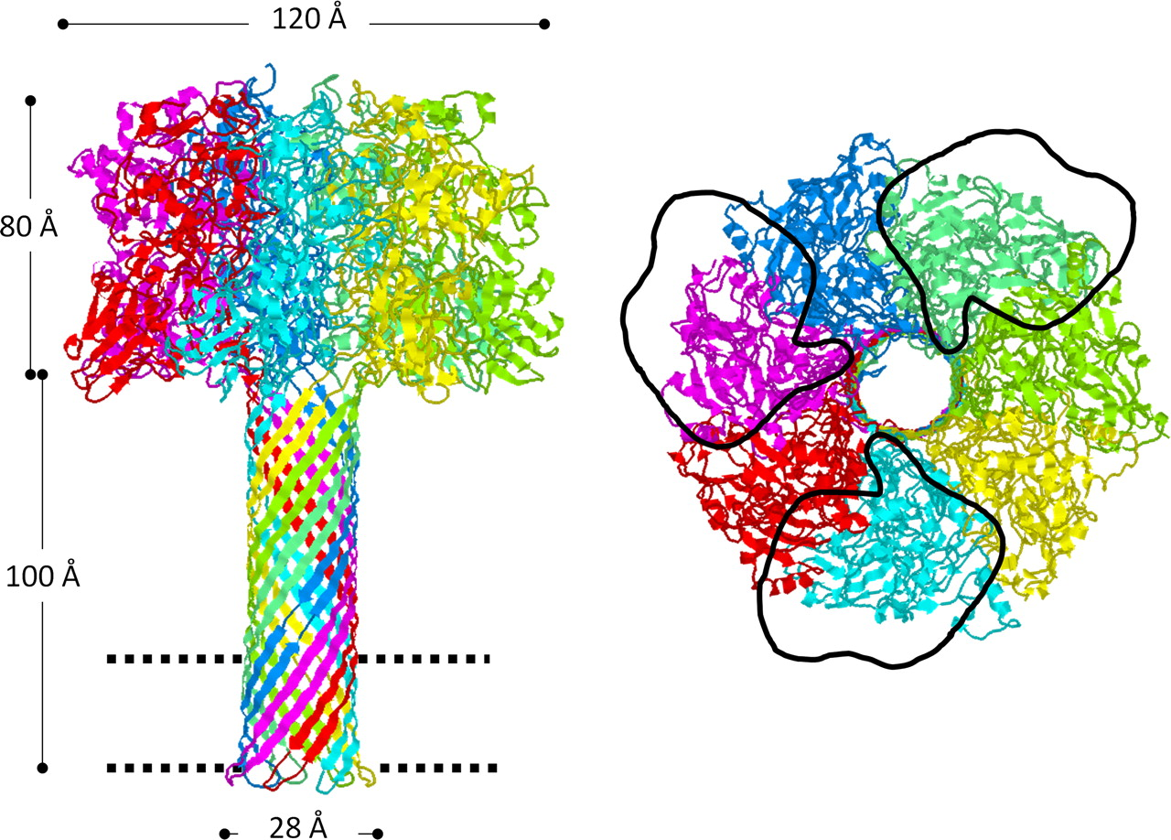

<http://classes.midlandstech.com/carterp/Courses/bio225/chap05/img002.jpg>

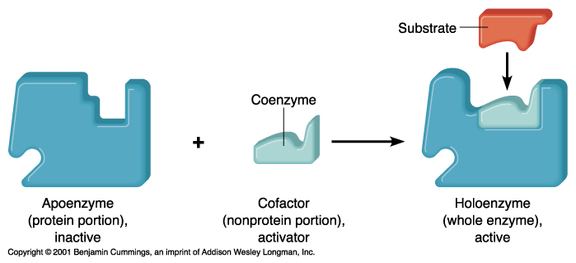

<http://classes.midlandstech.com/carterp/Courses/bio225/chap05/05-08_Feedback_1.jpg>

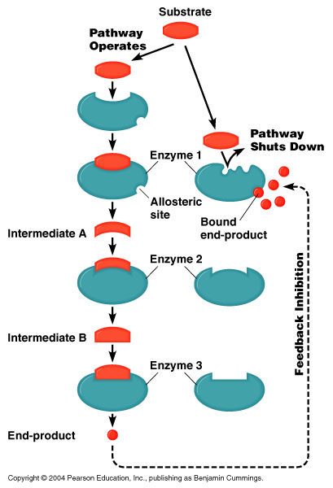

<http://academic.pgcc.edu/~kroberts/Lecture/Chapter%205/05-10_CompInhibition_L.jpg>

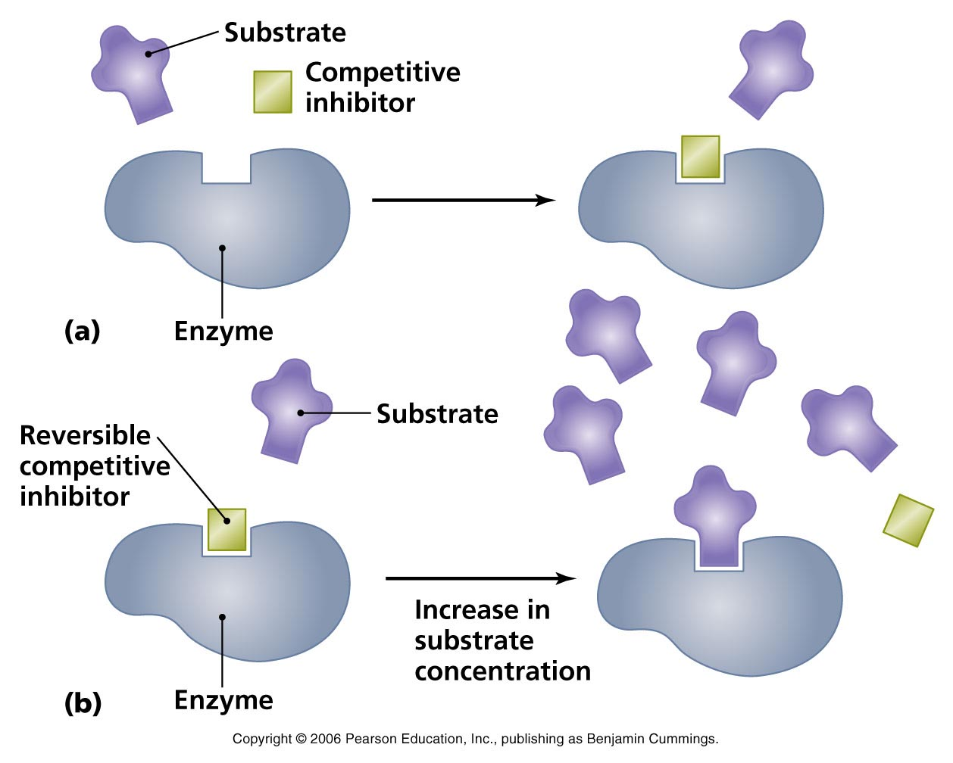

<http://academic.pgcc.edu/~kroberts/Lecture/Chapter%205/05-11_AllostericControl_L.jpg>

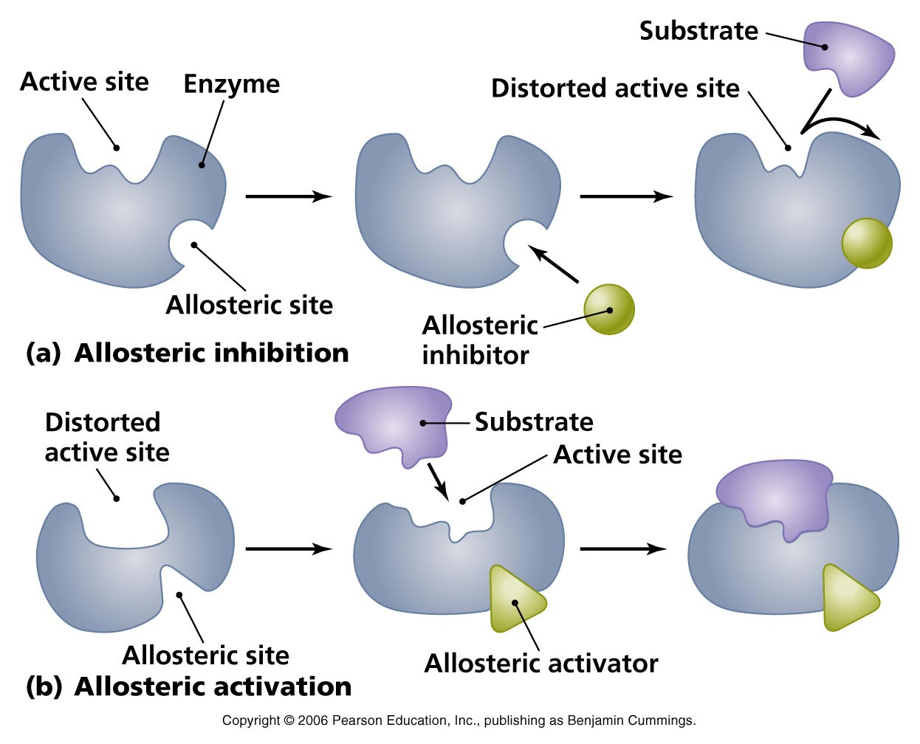

<http://employees.csbsju.edu/hjakubowski/classes/ch331/protstructure/membprottypes.gif>

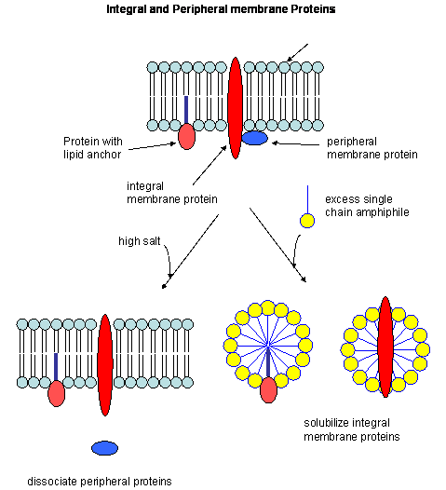

Seeley Anatomy & Physiology 6th Ed

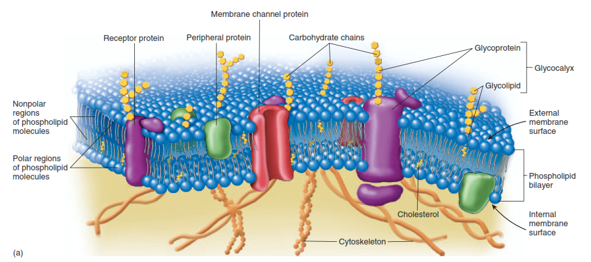

<http://study.com/cimages/multimages/16/channel_passive_and_active.png>

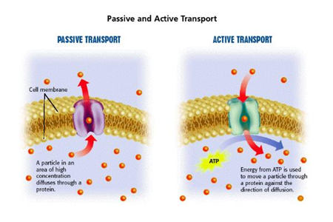

<http://eng.thesaurus.rusnano.com/upload/iblock/ba6/030_gelicokalics_1.jpg>

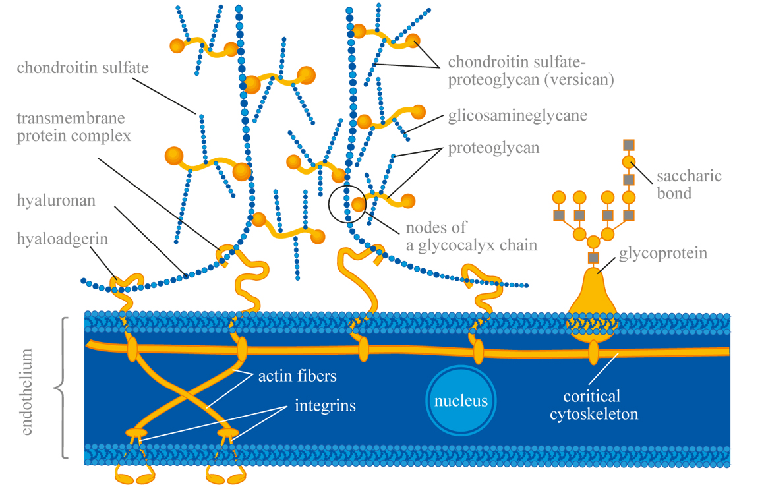

<http://www.william-hogarth.de/Glykokalyx.html>

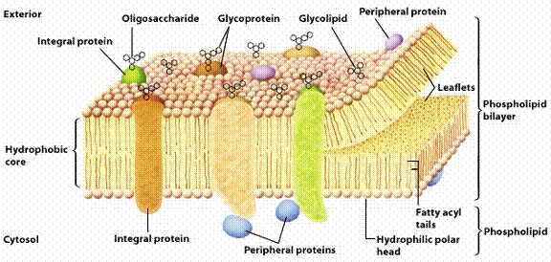

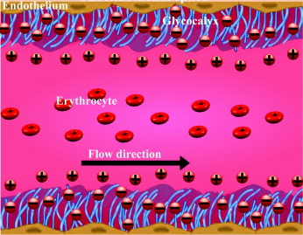

<https://vennofem.wordpress.com/2013/12/10/the-glycocalyx/>

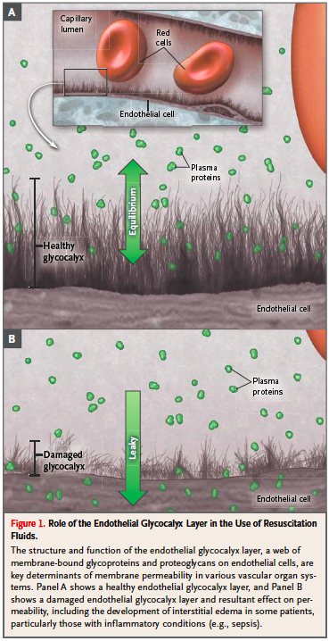

<http://www.whatisldl.com/low-density-lipoprotein/>

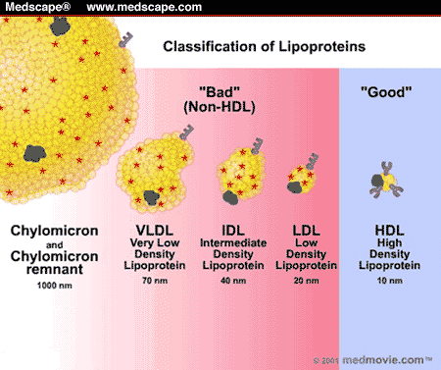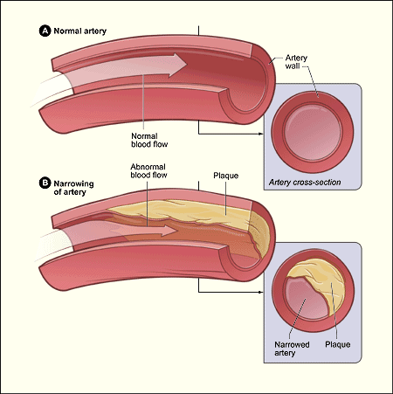

<https://usmle287.wordpress.com/category/biochemistry/>

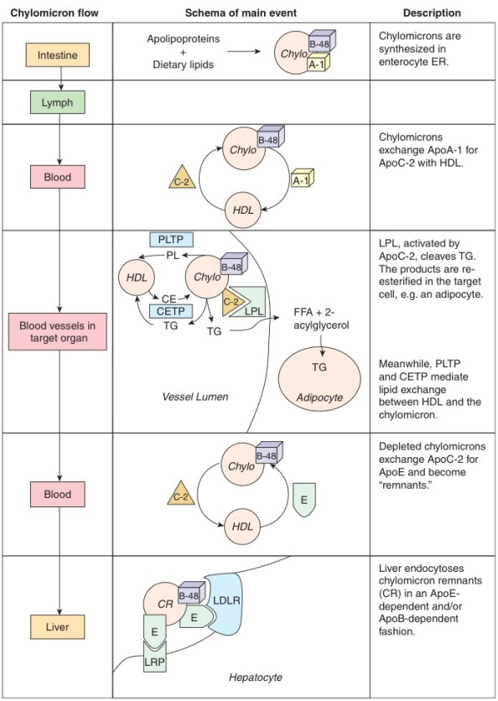

<http://www.scientificpsychic.com/health/lipoproteins-LDL-HDL.html>

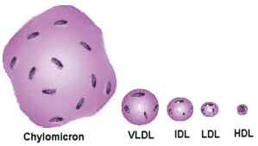

<https://cardiologydoc.wordpress.com/2012/05/27/understanding-the-cholesterol-skeptic/>

